Strand 3 Acid Rain (2010) 5163

A group of students wrote the following procedure for their acid rain investigation.

Procedure:
- Find the mass of each of three different building materials being tested.
- Pour 200ml of acidified water, pH 4.5, into each of three clean containers.
- Place each sample of building material into one of the three containers.
- After two days, remove the samples, wash them with distilled water, and allow them to dry completely.
- Mass each sample.

The chart below shows the students’ investigation results.
Material | Starting Mass (g) | Ending Mass (g) | Difference in Mass (g) | Percent Loss
Granite | 6.2 | 6.2 | 0.0 | 0.0
Marble | 8.7 | 8.1 | 0.6 | 6.9
Limestone | 5.3 | 4.1 | 1.2 | 22.6

- What was the problem the students were investigating?
- Describe two things the students could do to increase confidence in their results.

Rubric For Acid Rain Investigation

Possible Correct Responses:

Possible Problem:
− How does acid rain affect the mass of different building materials?
− What type of building material holds up best in acid rain conditions?
− What is the best type of building material to use outdoors?
− What type of building material will degrade most quickly in acid rain conditions?
− Other reasonable questions/problems

Increase Confidence:
− perform additional trials using the same building materials
− add a control to their investigation
− perform additional trials using water with different acidities
− use samples that have the same surface area/same amount of material
− use samples that have the same starting mass
− let the samples sit in vinegar for a longer amount of time
− make sure the temperature of the solvent is held constant for each sample
− other acceptable responses

3-Point Rubric:

Score 3
The response describes a problem that could be investigated based on the procedure and data and
describes two things the students could do to increase confidence in their results.

Score 2
The response provides a problem that could be investigated based on the procedure and data and
describes one thing the students could do to increase confidence in their results.
-or-
The response describes two things the students could do to increase confidence in their results, but fails
to or incorrectly describes a problem.

Score 1
The response describes a problem that could be investigated based on the procedure and data, but fails to or incorrectly describes two things the students could do to increase confidence in their results.
-or-
The response describes one thing the students could do to increase confidence in their results, but fails to or incorrectly describes a problem.

Score 0
The response provides little or no correct information.

Sample Student Responses

Response #1 (3)
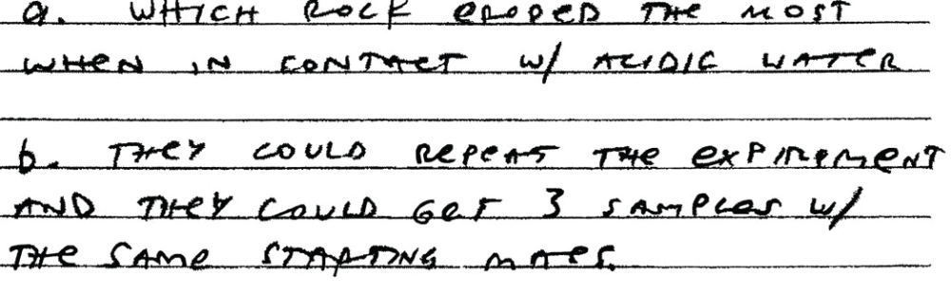

Response #2 (2)
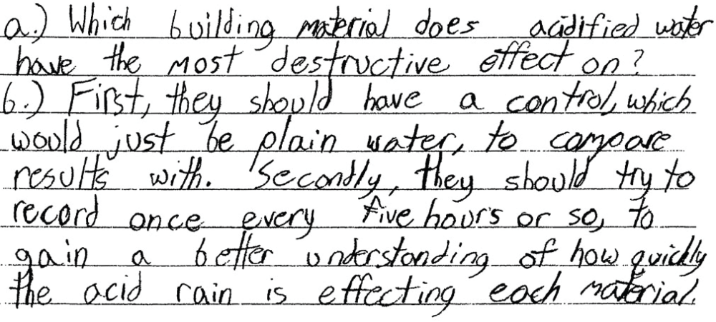

Response #3 (1)
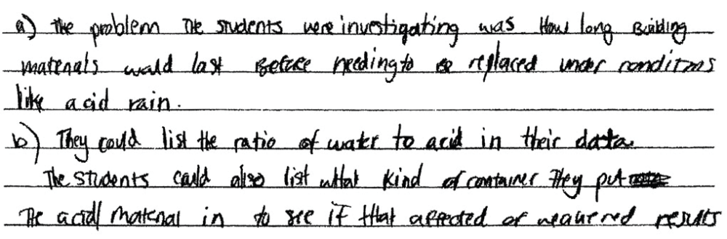

Response #4 (0)
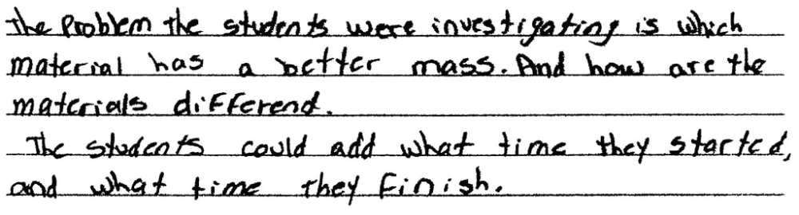
Response #5
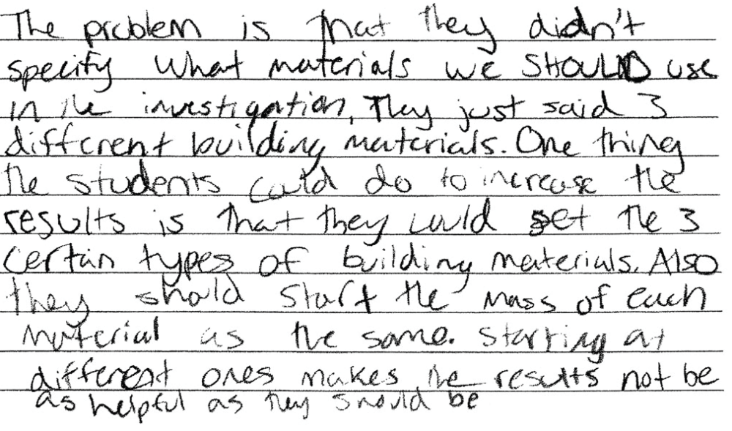

Response #6


